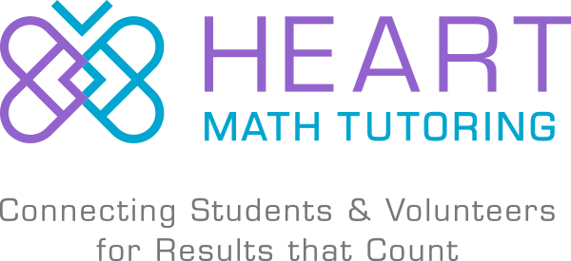 |  | Mission: Ensuring that all students build the strong foundation in math and enthusiasm for academics needed for long-term success,  by helping schools use volunteers as tutors.
2020-21 Preliminary Interest Form
Directions:  Please return this form and your responses to padgett.vaughn@hearttutoring.org or PO Box 30623, Charlotte NC 28230-0623.  Heart staff can answer questions and help you determine if the program is a fit for your school. Contact Padgett Vaughn at padgett.vaughn@hearttutoring.org or 704-651-2133.  Heart Math Tutoring will use this form to help identify new school partners for 2020/21 and to make long-term plans to meet the needs in CMS. Heart will be securing funding from philanthropy between now and June 2020 and will bring the program to at least 4 new school partners in fall 2020. A financial contribution from schools is also required. | Please review the information and resources at  www.hearttutoring.org/become-a-school-partner
School Info and Signature:

- School Name: ____________________________
- # of Students in K-5: ______________________
- 201/818 Math Proficiency Rate: ____________
- Name of Math Facilitator or Main Point of Contact: __________________________________
- Email of Math Facilitator or Main Point of Contact: __________________________________
- Phone Number of Math Facilitator or Main Point of Contact: __________________________________
- Principal Signature: A signature below indicates that your school may be interested in the program and that you would like to discuss further.

__________________________________ _______________________________ ________________________
Principal Name Principal Signature Date

Questions:
Please attach a separate single sheet addressing these questions. Ideally this will take 10 - 20 minutes and involve input from your school’s math team, principal, and a staff member who is knowledgeable about existing school partnerships.

- How would you use Heart Math Tutoring to complement your school’s math remediation or intervention plans?
- Which teachers and grade levels use Kathy Richardson’s Assessing Math Concepts, and to what extent (if any)?
- What other math resources or curriculum does your school use? (E.g., Do The Math, Investigations, teacher-created materials, technology programs) Please include any additional comments about your school’s instructional philosophy in math.
- With Heart, your school would need to designate two hours during the school day when various grade levels could be pulled for tutoring. Would your school be able to designate two tutoring hours, and what would those hours be (i.e. 8:00-8:30 2nd grade, 8:30-9:00 4th grade, 12:00-1:00 1st & 5thgrade)? Please reach out to Padgett if you need to discuss!
- Can you provide space for a group of 14 tutor/student pairs (28 people) during the two designated tutoring hours? Please see examples of flexible space options on the school partner agreement. What space would you provide?
- Please list any school community partners (e.g., faith-groups, businesses, service groups, university partners). Please indicate whether you believe partners might be interested in providing volunteer tutors for Heart.
- How would your school plan to allocate funds for the financial contribution of $5,000 for new schools (i.e. Title I funds, Extended Day, PTA)?*

*The cost of operating Heart at a school site for one year is $50,000. Heart requires schools to contribute $10,000 (20%) and raises the rest through philanthropy.

